Curriculum Vitae DR KUNDAN SINGH CHUFAL

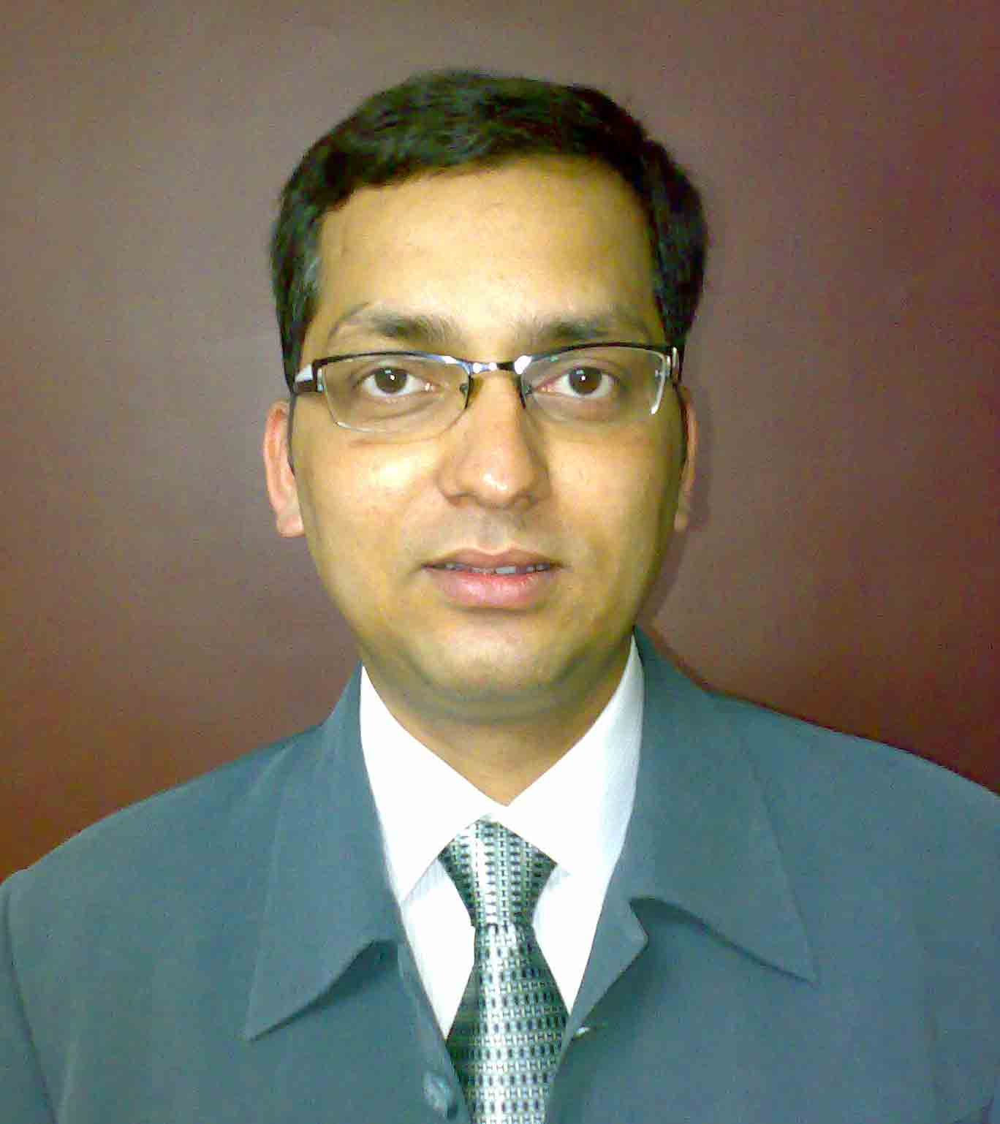
Name Dr. Kundan Singh Chufal
Date of Birth 25th May, 1974
Gender Male
Nationality Indian
Marital Status Married
Father’s Name Late Shri B. Singh

Address:

Current: Permanent:
Department of Radiation Oncology 22/98 Indira Nagar
Batra Hospital & Medical Research Centre Lucknow (U.P, India)
1, Tughlakabad Institutional Area, Mehrauli Badarpur Road Pin -226016, (India)
New Delhi – 110062 Phone: 05222346107
Office Phone: 0522-2257563 Ext 2037
Home Phone: 011-26365873 Mobile: 09811715853
Website: http://www.radiotherapy.in
E-mail: kundan_25@rediffmail.com, kundan_25@radiotherapy.in

CAREER OBJECTIVE

I want to pursue a career in Radiation Oncology. At the threshold of my career, I look forward to realize my full potential….to realize my dreams in this field.

EDUCATIONAL QUALIFICATIONS

Year | Institute/School | Degree/Examination | Percentage
November 2003 | Department of Radiotherapy K.G.M.C. Lucknow | M. D. (Radiotherapy) | Passed (1st attempt )
1993-1998 | S.N. Medical College, Agra | M.B.B.S | 57.44%(average of all 3 professionals).
1992 | H.A.L School, Lucknow | A.I.S.S.C.E. (CBSE, New Delhi) | 70.8%
1990 | H.A.L School, Lucknow | A.I.S.S.E. (CBSE, New Delhi) | 73.8%

PROFESSIONAL ACHIEVEMENTS

- Cleared UPPGME (Uttar Pradesh Postgraduate Medical Entrance Examination) in first attempt in 2000.
- Qualified in Combined Pre-Medical Entrance Examination, 1993.
- Life Member of Association of Radiation Oncologist of India (AROI). (Membership no. LM-747 )
- International Member American Society for Therapeutic Radiology and Oncology (Membership no. 35156680)
- Member Editorial Board World Journal of Radiology
- Member Editorial Board Cancer Therapy Journal
- Delhi Medical Council Registration no. 21555
- U.P. Medical Council Registration no. 943706

INTERNSHIP - District Hospital Bareilly DEC 1998 TO DEC 1999

- 1 year rotatory Internship from District Hospital ,Barielly, U.P, India.
- 2 months posting each in Departments of Medicine ,Gynaecology , Surgery and 6 months posting in Department of Social and Preventive Medicine which included posting at a Primary Health Center

THESIS

M.D. (Radiotherapy) Department of Radiotherapy K.G.M.C. Lucknow

October, 2001 – November 2002

Topic: To study the role of radiation with concurrent late chemotherapy intensification (Chemoboost) for locally advanced head and neck cancer

Scope: The concurrent late chemotherapy intensification (chemoboost) regimen was devised by extrapolating the findings from fractionation studies using radiation alone to combined modality treatment. The rationale was that with radiation therapy alone the most effective time for a concomitant boost has been shown to be the last 2 weeks of radiation therapy. It is recognized that chemotherapy given concurrently with radiation therapy is more effective than when given sequentially hence, the extrapolation of giving chemotherapy as the boost in the last 2 weeks of radiation therapy. Smaller radiation fields are in use with smaller mucosal volumes receiving combined therapy, thus increasing patient tolerance; and It increases treatment intensity to the tumor dense volumes in a time period where accelerated repopulation of surviving clonogens is known to occur during treatment It is unnecessary to give chemotherapy concurrently with initial (large) radiation volumes, where radiation therapy alone is capable of sterilizing sub-clinical disease. By delivering the systemic therapies at the end of the radiation, we believed patients would be able to tolerate the therapy best because the toxic effect will not occur until the later portion of the therapy.

CLINICAL TRAINING

- 1year Internship from Dist. Hospital Barielly.

- Three year postgraduate training as Junior Resident at the Department of Radiotherapy K.G.M.C., Lucknow.

- Three year Senior Residency at Batra Cancer Centre, Batra Hospital since December 2003 to December 2006
- Worked as Associate consultant at Batra Cancer Centre, Batra Hospital since December 2006 to October 2008.
- Presently working as Senior Consultant Radiation Oncology at Batra Cancer Centre, Batra Hospital since November 2008.
- Holding a post of Director of website www.radiotherapy.in

CLINICAL EXPERIENCE

Worked as a Junior Resident for the past 3 years at the Department of Radiotherapy, King George’s Medical University, Lucknow and Senior Resident for next three year at Batra Hospital & Medical Research Centre. Now working as a Senior Consultant in Department of Radiation Oncology, Batra Hospital and Medical Research Centre since November 2008. The current department is well equipped with two Dual Energy Linear Accelerator (Simens Mevatron MD2 and Varian Clinac 2100C) with Electrons, Compensator and MLC based IMRT and Microselectron HDR brachytherapy. I am comfortable with:

- External Beam Radiotherapy planning (Cobalt 60, Linear Accelerator and Electrons)
- HDR Brachytherapy : Intracavitry Radiotherapy for Cervix and Uterus, Intraluminal and endobronchial for Esophagus and Lung and Interstitial Implant for breast, Anal canal and Head and Neck region
- Target Delineation, Plan evaluation and implementation for 3D conformal and intensity modulated Radiotherapy on Eclipse & Plato planning software.
- IMRT (Plato and Eclipse) for Head and Neck, Prostate Cancer and others.
- IGRT for prostate cancer using gold seed implants and EPID.
- We have a multi-disciplinary approach, which involves Surgical Oncologists Pediatric oncologists, medical oncologists and pathologists. Once in a week all the above mentioned specialties meet at tumor board to discuss interesting and challenging cases.
- As a Senior consultant I am involved in DNB teaching program, Independently handling OPDs, ward rounds, brachytherapy and external beam radiotherapy treatment planning and evaluation.
- Involved in organizing CMEs and symposiums and delivered talks in these forums.
- Presented papers in international and national conferences.

CONFERENCES ATTENDED

- International Symposium on Prognostic and Predictive Factors in Cancer Management held on 15th & 16th December 2008 at King George's Medical University Lucknow.
- Workshop on brachytherapy on 14th December 2008 at King George's Medical University Lucknow.
- 12th International congress on oral cancer. 22nd May – 25th May, 2008, Shanghai, China.
- Batra Hospital North Zone AROI CME – 2008. IMRT: Site specific management modules 16th March 2008, New Delhi.
- TMH Mumbai 6th evidence based management of cancers in India – 2008. Conference on CNS tumors. 29th February – 2nd March 2008.
- 29th National Conference of AROI 29th November to 2nd December 2007, Chennai, Tamilnadu, India.
- Lancet Asia Medical Forum. Suntec city Singapore 21st - 22nd April 2007
- 28th National Conference of AROI 30th November to 3rd December 2006, Banaras, U.P, India.
- ASTRO 48th Annual Meeting 2006, Philadelphia, USA November 5th to 9th 2006
- RGCON 2006, Head & Neck Oncology 5Th International conference, RGCI, Delhi 18th and 19th March.
- 27th National Conference of AROI 25th to 28th November 2005, Ahmedabad, Gujrat
- ONCON 2005, National Symposium on Gyne Oncology, Lucknow Cancer Institute Lucknow.
- International Symposium on Target Volume Delineation in Head and Neck and Brain Tumors for IMRT, 2005, Delhi
- ESTRO International Symposium held at Tata Memorial Hospital 2005. Evidence Based Management guidelines for head and neck, cervical and urological cancer.
- RGCON 2005, 4th International Conference on uro-oncology 12th and 13th March RGCI Delhi.
- 26th National Conference of AROI 25th to 28th November 2004, Ludhiana
- 25th National Conference of AROI 21st to 24th November 2003, Kochi
- 24th National Conference of AROI 21st to 24th November 2002, Bangalore
- XVI U.P Chapter AROI Convention – 2002 , 19th and 20th October 2002, Kanpur
- ONCON – 2002 Lucknow Cancer Institute, 8th June 2002, Lucknow
- Breast Cancer Foundation – India 6th Annual Conference, 7th and 8th march 2002, Goa
- CME Oncology Update 2001, Allahabad
- XV U.P. Chapter Convention 2001 AROI, 6th October 2001, Bareilly
- XIV U.P Chapter Convention 2001 AROI, 29th April 2001, Lucknow
- National Symposium on Carcinoma Gallbladder 16th March 2001 Lucknow

RESEARCH, PAPER PRESENTATION & TALK

At 23rd UP Chapter AROI Convention held on 24th & 25th October 2008 at Naukuchiyatal, Uttranchal, India.

- Guest Speaker: Innovative radiation approaches in head neck cancer: Maximizing control & minimizing toxicity.

At International Symposium on Prognostic and Predictive Factors in Cancer Management held on 15th & 16th December 2008 at King George's Medical University Lucknow.

- Invited Speaker: Predictive & prognostic factors in carcinoma cervix.

At Workshop on brachytherapy held on 14th December 2008 at King George's Medical University Lucknow.

- Invited Speaker: Brachytherapy for breast cancer.

At 12th international congress on oral cancer. 22nd May – 25th May, 2008, Shanghai, China.

- Invited Key note Speaker: Integrating other therapies with radiation for head neck cancer: Search for optimal solution.

At Batra hospital north zone AROI CME 16th March 2008, New Delhi.

- Invited Speaker: Intensity modulated radiation therapy for Oropharynx and laryngeal tumors: Target delineation and clinical results.

At ASTRO 48th Annual Meeting 2006, Philadelphia, USA

- Paper presentation: Intensity Modulated Radiotherapy Using Compensators for Head And Neck Cancer Patients: Impact of Dosimetric Parameters on Clinical Outcome.

At 26th National Conference of AROI November 2004 Ludhiana

- Paper presentation: Intensity modulated radiation therapy for head and neck cancer: Our experience in achieving dosimetric parameters.

At 25th National Conference of AROI November 2003 Kochi

- Paper presentation: The Impact Of Tumor Volume And Density Measurement On Local Control In Advanced Head And Neck Cancer Using Chemoboost Regimen

At 24th National Conference of AROI November 2002 Banglore

- Paper presentation: To study the role of radiation with concurrent late chemotherapy intensification (chemoboost) for locally advanced head and neck cancer.

AT XVI U.P Chapter AROI Convention – 2002,Kanpur
- Paper presentation: Definitive Radiotherapy For Carcinoma Of The Uterine Cervix: Retrospective Analysis Of Prognostic Factors Concerning Patient Characteristics And Treatment Parameters.

AT Breast Cancer Foundation meet – March 2002, Goa.

- Paper presentation: A Prospective Study Comparing Two Different Radiotherapy Fractionation Schedules For Assessing The Responsiveness Of Bone Metastases In Breast Cancer Patient

AT XVI U.P Chapter AROI Convention – 2001, Bareilly
- Paper presentation: Cisplatin And Infusional 5-Fluorouracil Concomitantly With Radiation In Esophageal Malignancy

INTERNATIONAL PUBLICATIONS

- Case Report: Multiple skin metastases in forearm from base tongue carcinoma – A case report, Journal: Oral Oncology Extra doi:10.1016/j.ooe.2005.05.004
- Original Article: Rastogi M, Srivastava M, Chufal KS, Pant MC, Srivastava K, Bhatt MB. Mitomycin and fluorouracil in combination with concomitant radiotherapy: a potentially curable approach for locally advanced head and neck squamous cell carcinoma. Jpn J Clin Oncol. 2005 Oct;35(10):572-9. Epub 2005 Sep 26. Erratum in: Jpn J Clin Oncol. 2006 Feb;36(2):121. PMID: 16186175 [PubMed - indexed for MEDLINE]
- Original Article: Chufal KS, Rastogi M, Srivastava M, Pant MC, Bhatt ML. Late chemo-intensification with cisplatin and 5-fluorouracil as an adjunct to radiotherapy: A pragmatic approach for locally advanced head and neck squamous cell carcinoma. Oral Oncol. 2006 May;42(5):517-25. Epub 2006 Feb 9. PMID: 16480913 [PubMed - indexed for MEDLINE]
- Original Article: Nangia S, Chufal K.S, Arivazhagan V, Srinivas P, Tyagi A, Ghosh D. Compensator based Intensity Modulated Radiotherapy in head and neck cancer: Our experience in achieving dosimetric parameters and their clinical correlation. Clin Oncol (R Coll Radiol). 2006 Aug;18(6):485-92. PMID: 16909973 [PubMed - indexed for MEDLINE]
- Original Article: Rastogi M, Bhatt M, Chufal K.S. et al. Esthesioneuroblastoma treated with non-craniofacial resection surgery followed by combined chemotherapy and radiotherapy: An alternative approach in limited resources. Jpn J Clin Oncol. 2006 Oct;36(10):613-9. Epub 2006 Aug 22. PMID: 16926225 [PubMed - indexed for MEDLINE]
- Original Article: Chufal KS, Rastogi M, Srivastava et al. Analysis of prognostic variables among patients with locally advanced head and neck cancer treated with late chemo-intensification protocol: impact of nodal density and total tumor volume. Jpn J Clin Oncol. 2006 Sep;36(9):537-46. Epub 2006 Aug 12. PMID: 16905755 [PubMed - indexed for MEDLINE]
- Abstract: K. S. Chufal, S. Nangia, A. Tyagi, V. Arivazhagan, P. Srinivas, D. Ghosh. Intensity Modulated Radiotherapy Using Compensators for Head And Neck Cancer Patients: Impact of Dosimetric Parameters on Clinical Outcome. Accepted for poster presentation at ASTRO 2006 annual meeting at Philadelphia and was published in International Journal of Radiation Oncology Biology Physics, Volume 66, Issue 3, Pages S453-S454.
- Original Article: Kundan S. Chufal, Madhup Rastogi, Madhu Srivastava, M.C. Pant, M.L.B. Bhatt, Kirti Srivastava. Concurrent chemoradiotherapy for locally advanced cervical cancer using Gemcitabine: non-randomized comparison of three sequential protocols. Cancer Therapy 2007, Volume 5A, Pages 43 - 54.
- Abstract: SU-GG-T-164. A Tyagi, S Nangia, K Chufal, M Mishra, D Ghosh, M P Singh. Quality Assurance and Dosimetric Analysis of Intensity Modulated Radiotherapy Using Compensators for Head and Neck Cancers. AAPM Annual Meeting 2008.
- Letter to the editor: Aggression and innovation rather than palliation. K.S.Chufal, Sapna Nangia. Radiotherapy and Oncology, article in press, doi:10.1016/j.radonc.2008.08.004.
- Original Article: Sapna Nangia, Kundan S. Chufal, Atul Tyagi, Anshul Bhatnagar, Manindra Mishra, D. Ghosh. Selective Nodal Irradiation for Head and Neck Cancer Using Intensity-Modulated Radiotherapy: Application of RTOG Consensus Guidelines in Routine Clinical Practice. International Journal of Radiation Oncology*Biology*Physics, In Press, Corrected Proof, Available online 24 June 2009
- Original Article: Kundan S Chufal et al. Exploring new potentials and generating hypothesis for the management of locally advanced head neck cancer: Analysis of pooled data from two phase II trial. Journal of Cancer Research and Therapeutics (Article in press)
- Original Article: Atul Tyagi, Sapna Nangia, Kundan S Chufal et al. Quality assurance and dosimetric analysis of intensity modulation radiotherapy using compensators for head and neck cancers. Pol J Med Phys Eng 2009;15 (Article in Press)

I confirm that all information here is correct and to the best of my knowledge.

Date: 11 May 2010
Place: New Delhi, India

